Ulfried Haselsteiner, Tenor

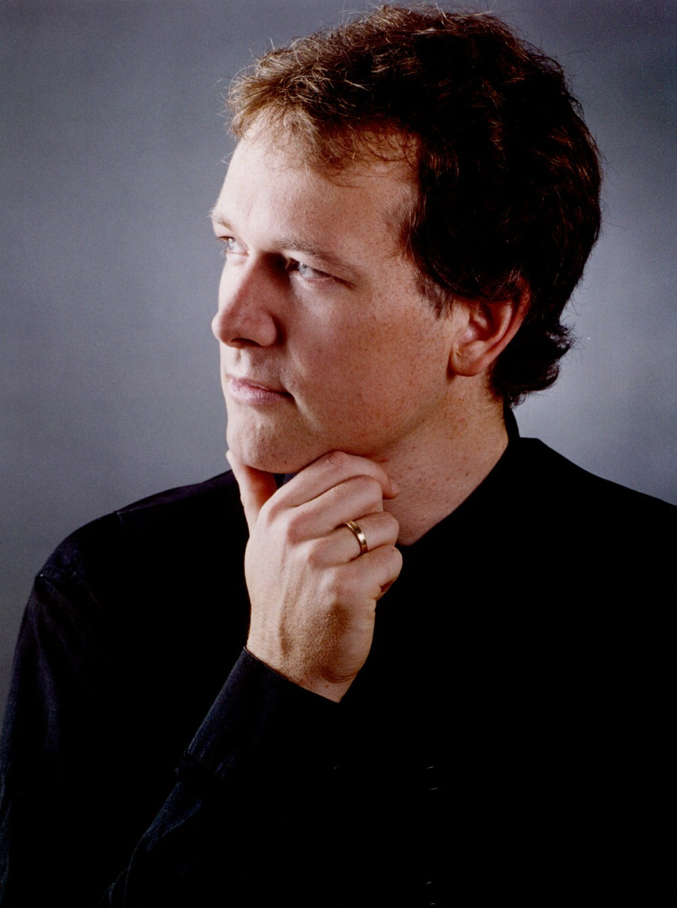
Born in Lienz, Austria, Ulfried Haselsteiner studied at the opera-class of the University "Mozarteum" in Salzburg taking singing lessons with Eva Illes and Boris Bakow. He graduated "cum laude" performing Hoffmann in Offenbachs "Les contes d'Hoffmann".

He was awarded the "Hanna-Ludwig-Price" for the years best singing-acting performance as Hoffmann and Alviano (Schreker: Die Gezeichneten).

In addition, he has attended Master classes with Bernd Weikl and Sherill Milnes.

In october 1999 he made his debut as Max in C.M.Webers "Freischütz" at the State Opera Prague.

Since then he has been a guest artist at various opera houses in europe and japan.

At the Teatro lirico Cagliari he sang Da-ud in the italian premiere of Richard Strauss' "Die Ägyptische Helena".
This performance is available on CD.

Ulfried Haselsteiner did Tamino (Mozart: Zauberflöte) at the Staatstheater Kassel, at Bunka Kaikan Tokyo and at the Opernfestival Klosterneuburg/Vienna.

At the deutsche Oper Berlin and at the National Dutch Reisoper he performed Graf von Hohenzollern (H.W. Henze: "Der Prinz von Homburg")

At the Grand Théâtre de Genève: Richard Wagners Tannhäuser (Schreiber/Walter), Janaceks "From the house of the dead " (Velky Vezen/Cerevin) and 2006 in the world premiere of Michael Jarrells "Galileo" as Ludovico.

Other important opera houses he performed at: the Gran Teatre Liceu Barcelona, Teatro dell'Opera Roma, Teatro Massimo Palermo, Teatro Regio Torino, the National Theatre Mannheim, the Salzburger Festspiele, the Festival Erl

He has worked with various artists : Fabio Luisi, Peter Schneider, Gustav Kuhn, Andreas Homoki, Günter Krämer, Nicolas Brieger, Robert Carsen, Stephen Medcalf or Olivier Pi.

His most important opera parts are : Max (Freischütz), Tamino (Magic Flute), Hans (Bardered Bride), Nerone (Incoronazione di Poppea), Graf Hohenzollern (Prinz von Homburg), Da-ud (Ägyptische Helena), Alfred/Eisenstein (Fledermaus), Rene (Madame Pompadour), Walther (Tannhäuser), Oedipe (Oedipus Rex).

